**MySQL Basic SELECT statement [19 Exercises]**

**1.** Write a query to display the names (first_name, last_name) using alias name "First Name", "Last Name"

**Answer:-**

[SELECT](http://localhost/phpmyadmin/url.php?url=https://dev.mysql.com/doc/refman/8.0/en/select.html) FIRST_NAME as 'First Name',LAST_NAME as 'Last Name' from employees;

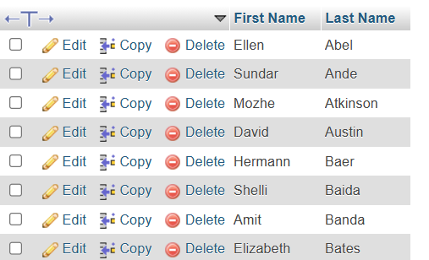

**2.** Write a query to get unique department ID from employee table.

**Answer:-**

[SELECT](http://localhost/phpmyadmin/url.php?url=https://dev.mysql.com/doc/refman/8.0/en/select.html) DISTINCT DEPARTMENT_ID FROM employees;

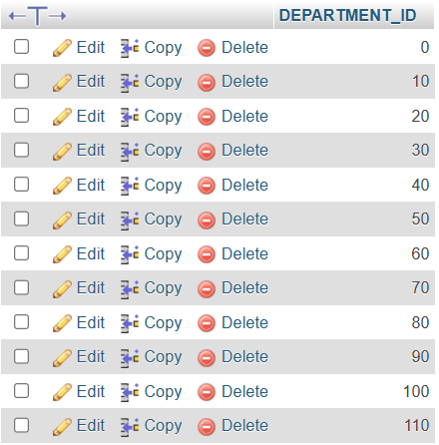

**3.** Write a query to get all employee details from the employee table order by first name, descending.

**Answer:-**

[SELECT](http://localhost/phpmyadmin/url.php?url=https://dev.mysql.com/doc/refman/8.0/en/select.html) * FROM employees ORDER BY FIRST_NAME DESC;

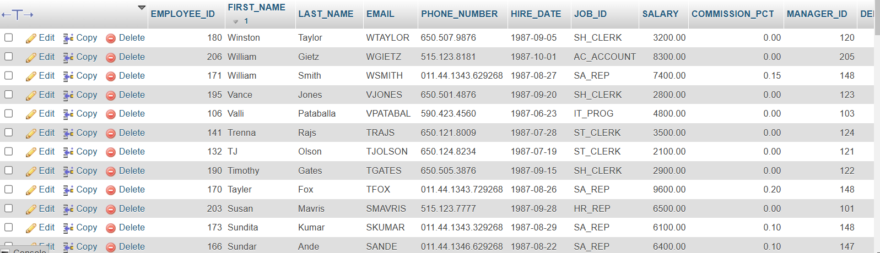

**4.** Write a query to get the names (first_name, last_name), salary, PF of all the employees (PF is calculated as 15% of salary).

**Answer:-**

[SELECT](http://localhost/phpmyadmin/url.php?url=https://dev.mysql.com/doc/refman/8.0/en/select.html) FIRST_NAME,LAST_NAME,SALARY,SALARY*0.15 AS PF FROM employees;

OR

[SELECT](http://localhost/phpmyadmin/url.php?url=https://dev.mysql.com/doc/refman/8.0/en/select.html) FIRST_NAME,LAST_NAME,SALARY,SALARY*0.15 AS 'PF' FROM employees;

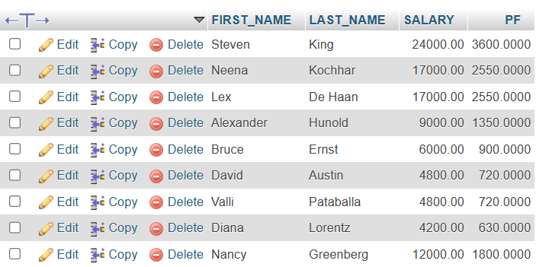

**5.** Write a query to get the employee ID, names (first_name, last_name), salary in ascending order of salary.

**Answer:-**

[SELECT](http://localhost/phpmyadmin/url.php?url=https://dev.mysql.com/doc/refman/8.0/en/select.html) EMPLOYEE_ID,FIRST_NAME,LAST_NAME,SALARY FROM employees ORDER BY SALARY ASC;

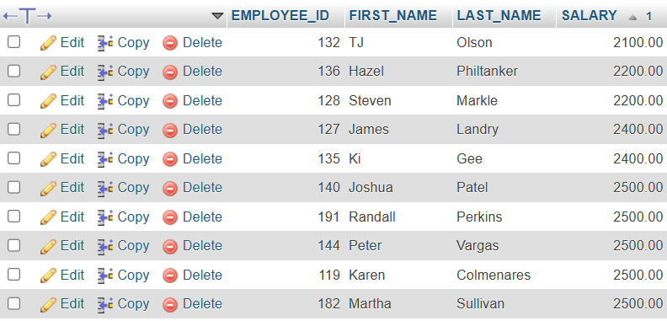

[SELECT](http://localhost/phpmyadmin/url.php?url=https://dev.mysql.com/doc/refman/8.0/en/select.html) EMPLOYEE_ID,FIRST_NAME,LAST_NAME,SALARY FROM employees ORDER BY SALARY DESC;

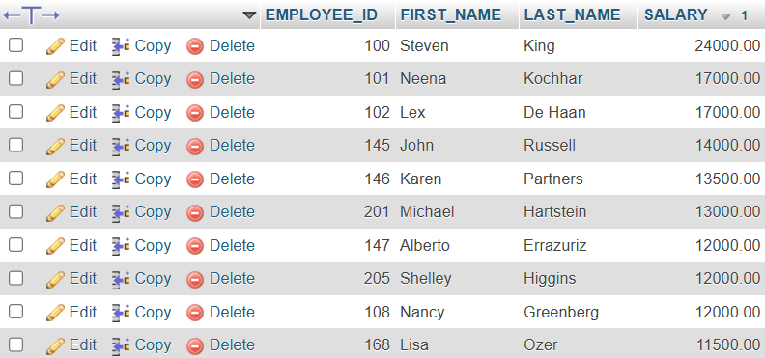

**6.** Write a query to get the total salaries payable to employees.

**Answer:-**

[SELECT](http://localhost/phpmyadmin/url.php?url=https://dev.mysql.com/doc/refman/8.0/en/select.html) [SUM](http://localhost/phpmyadmin/url.php?url=https://dev.mysql.com/doc/refman/8.0/en/aggregate-functions.html%23function_sum)(SALARY) FROM employees;

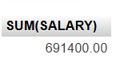

**7.** Write a query to get the maximum and minimum salary from employees table.

**Answer:-**

[SELECT](http://localhost/phpmyadmin/url.php?url=https://dev.mysql.com/doc/refman/8.0/en/select.html) [MAX](http://localhost/phpmyadmin/url.php?url=https://dev.mysql.com/doc/refman/8.0/en/aggregate-functions.html%23function_max)(SALARY),[MIN](http://localhost/phpmyadmin/url.php?url=https://dev.mysql.com/doc/refman/8.0/en/aggregate-functions.html%23function_min)(SALARY) FROM employees;

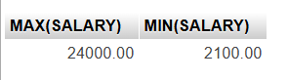

**8.** Write a query to get the average salary and number of employees in the employees table.

**Answer:-**

[SELECT](http://localhost/phpmyadmin/url.php?url=https://dev.mysql.com/doc/refman/8.0/en/select.html) [AVG](http://localhost/phpmyadmin/url.php?url=https://dev.mysql.com/doc/refman/8.0/en/aggregate-functions.html%23function_avg)(SALARY),[COUNT](http://localhost/phpmyadmin/url.php?url=https://dev.mysql.com/doc/refman/8.0/en/aggregate-functions.html%23function_count)(EMPLOYEE_ID) FROM employees;

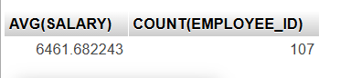

**9.** Write a query to get the number of employees working with the company.

**Answer:-**

SELECT COUNT(EMPLOYEE_ID) FROM employees;

OR

[SELECT](http://localhost/phpmyadmin/url.php?url=https://dev.mysql.com/doc/refman/8.0/en/select.html) [COUNT](http://localhost/phpmyadmin/url.php?url=https://dev.mysql.com/doc/refman/8.0/en/aggregate-functions.html%23function_count)(*) AS NumberOfEmployee FROM employees;

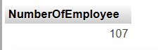

**10.** Write a query to get the number of jobs available in the employees table.

[SELECT](http://localhost/phpmyadmin/url.php?url=https://dev.mysql.com/doc/refman/8.0/en/select.html) [COUNT](http://localhost/phpmyadmin/url.php?url=https://dev.mysql.com/doc/refman/8.0/en/aggregate-functions.html%23function_count)(DISTINCT job_id) AS Available_Jobs FROM employees;



**11.** Write a query get all first name from employees table in upper case.

**Answer:-**

[SELECT](http://localhost/phpmyadmin/url.php?url=https://dev.mysql.com/doc/refman/8.0/en/select.html) UPPER(FIRST_NAME) AS "FIRST NAME" FROM employees;

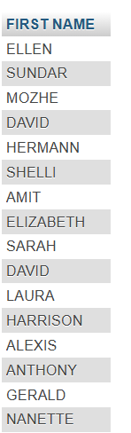

**12.** Write a query to get the first 3 characters of first name from employees table.

**Answer:-**

[SELECT](http://localhost/phpmyadmin/url.php?url=https://dev.mysql.com/doc/refman/8.0/en/select.html) SUBSTRING(FIRST_NAME,1,3) AS "FIRST NAME" FROM employees;

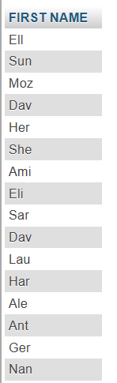

**13.** Write a query to calculate 171*214+625

[SELECT](http://localhost/phpmyadmin/url.php?url=https://dev.mysql.com/doc/refman/8.0/en/select.html) (171*214+625) RESULT;

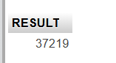

**14.** Write a query to get the names (for example Ellen Abel, Sundar Ande etc.) of all the employees from employees table.

**Answer:-**

[SELECT](http://localhost/phpmyadmin/url.php?url=https://dev.mysql.com/doc/refman/8.0/en/select.html) CONCAT(FIRST_NAME,' ',LAST_NAME) EMPName FROM employees;

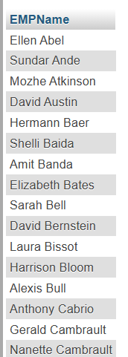

**15.** Write a query to get first name from employees table after removing white spaces from both side.

**Answer:-**

[SELECT](http://localhost/phpmyadmin/url.php?url=https://dev.mysql.com/doc/refman/8.0/en/select.html) TRIM(FIRST_NAME) FirstName FROM employees;

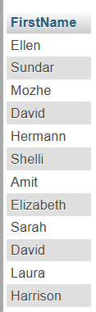

**16.** Write a query to get the length of the employee names (first_name, last_name) from employees table.

**Answer:-**

[SELECT](http://localhost/phpmyadmin/url.php?url=https://dev.mysql.com/doc/refman/8.0/en/select.html) FIRST_NAME,LAST_NAME,LENGTH(FIRST_NAME)+LENGTH(LAST_NAME) AS "Length Of Employee Names" FROM employees;

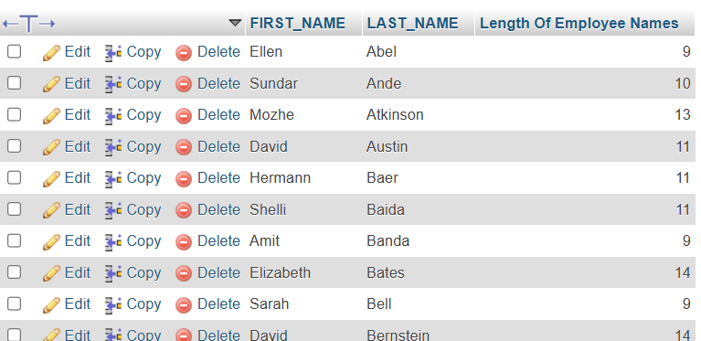

**17.** Write a query to check if the first_name fields of the employees table contains numbers.

**Answer:-**

[SELECT](http://localhost/phpmyadmin/url.php?url=https://dev.mysql.com/doc/refman/8.0/en/select.html) * FROM employees WHERE FIRST_NAME [REGEXP](http://localhost/phpmyadmin/url.php?url=https://dev.mysql.com/doc/refman/8.0/en/regexp.html%23operator_regexp) '[0-9]';

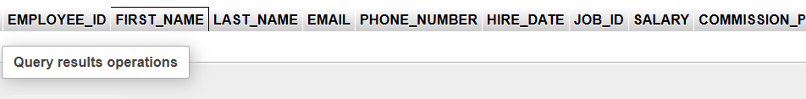

Note- Result not found hence we are update table here and again fire same querry.

UPDATE employees SET FIRST_NAME='123Abc' WHERE EMPLOYEE_ID=100;

[SELECT](http://localhost/phpmyadmin/url.php?url=https://dev.mysql.com/doc/refman/8.0/en/select.html) * FROM employees WHERE FIRST_NAME [REGEXP](http://localhost/phpmyadmin/url.php?url=https://dev.mysql.com/doc/refman/8.0/en/regexp.html%23operator_regexp) '[0-9]';



**18.** Write a query to select first 10 records from a table.

**Answer:-**

[SELECT](http://localhost/phpmyadmin/url.php?url=https://dev.mysql.com/doc/refman/8.0/en/select.html) EMPLOYEE_ID,FIRST_NAME FROM employees LIMIT 10;

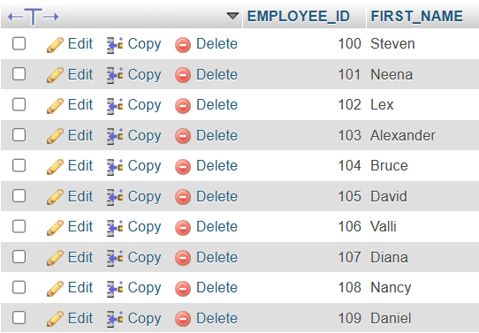

**19.** Write a query to get monthly salary (round 2 decimal places) of each and every employee  
Note : Assume the salary field provides the 'annual salary' information.

**ANS:-**

[SELECT](http://localhost/phpmyadmin/url.php?url=https://dev.mysql.com/doc/refman/8.0/en/select.html) EMPLOYEE_ID,FIRST_NAME,LAST_NAME,ROUND(SALARY/12,2) AS 'Monthly Salary' FROM employees;

